FORMAT OF COVER PAGE & FIRST PAGE

(Title of the Project)

A Dissertation submitted in partial fulfillment of the requirements for the award of degree of

MASTER OF COMPUTER APPLICATIONS

of

Visvesvaraya Technological University

By

STUDENT NAME
(USN Number)

Under the Guidance of
(Dr / Prof) GUIDE NAME
Designation



DEPARTMENT OF MASTER OF COMPUTER APPLICATIONS
R. V. COLLEGE OF ENGINEERING
MYSURU ROAD, R.V. VIDYANIKETHAN POST, BENGALURU – 560059
June 2017

INNER TITLE PAGE FORMAT

(Title of the Project)

A Dissertation submitted in partial fulfillment of the requirements for the award of degree of

Master of Computer Applications

of

Visvesvaraya Technological University

By

STUDENT NAME
(USN Number)

Under the Guidance of

Internal Guide External Guide
Guide Name Guide Name
Affiliation Affiliation
Address Address
Email: Email:

Department of Master of Computer Applications
R. V. College of Engineering, Mysuru Road
R.V. Vidyanikethan Post, Bengaluru – 560059

June 2017
COLLEGE CERTIFICATE

R. V. College of Engineering, Bengaluru
Department of Master of Computer Applications
Affiliated to Visvesvaraya Technological University, Belagavi
Approved by All India Council for Technical Education, New Delhi

CERTIFICATE

This is to certify that Student Name, USN No has completed his / her final semester project work
entitled ________________________________________________________________________________

as a partial fulfillment for the award of Master of Computer Applications degree, during the

academic year 2017 under my supervision.

Internal Guide
Name Name
Designation Professor and Director
Department of MCA Department of MCA

Principal
R. V. College of Engineering

I
Company Certificate

[For projects carried outside the college]

(Industry/Institute Certificate)

A certificate on the letter head of the Company/Institute with the signature and Seal of the external guide.

(The certificate should be taken for 5 months period of time without any specification of date)

II
Declaration

Declaration I, <Name of student>, student of 6th MCA, <College Name>, bearing USN <USN of student> hereby declare that the project entitled <Project Title> has been carried out by me under the supervision of External Guide /(or Guide) <Name of the Guide>, <Designation of Guide> and Internal Guide (or Co-guide) <Name of the Guide>, <Designation of Guide> and submitted in partial fulfillment of the requirements for the award of the Degree of Master of Computer Applications by the Visvesvaraya Technological University during the academic year 2017. This report has not been submitted to any other Organization / University for any award of degree or certificate.

Signature

Student Name:

III

Acknowledgement

(In order of Position)

(The order of acknowledgement should be head of the institution, Director, MCA, external guide, internal guide, further if any)

[contents]

IV
Abstract

It is a one page document consisting of the below paragraph

First para: Brief introduction about the project which should include background, Areas / type of applications, market size (if available) and hence the importance of the domain. Key developments in the domain, unresolved issues or/and new emerging opportunities in the domain areas and hence the problem or the issue that is proposed to be addressed in the project or the objective. If it is theory or simulation based add all the existing theory/algorithms names and what is it that the project is based on, their essentially advantage or drawbacks in brief and hence the motivation to work on the project.

Second Para : Methodology of your project including the key theory, design tools or software tools or / and the experimental tools that will be used, the key specifications including constrains or boundary conditions or approximations or assumptions that have been considered for the work. The sequence in which the work is to be carried out.

Third para : Key findings, results or outcome of the work including experimental data of the outcome or / and percentage in terms of working efficiency of the developed product or system.

V

Index

College Certificate I
Company Certificate II
Declarations by student III
Acknowledgement IV
Abstract V
Table of Contents VI
List of Tables and Figures VII

(For Application oriented Projects)

Chapter 1: Introduction Page No
  - Project Description
    - Background of the work
    - Basic Introduction of the Project – Minimum One paragraph
- (This should consist of the previous work related to the project either in the same company or any other organization with reference to the year of submission of the report – 2017) Basic Introduction of the Project Concept
- Theory and concept relevant to the project including details of process technology/ theoretical / experimental principles/ analytical models / numeric models/ type of algorithms etc based on the project type. (To be discussed with the Internal Project Guide).

  - Company Profile

Chapter 2: Literature Review Page No
2.1 Literature Survey
- Write a literature survey of references with respect to this chapter
- Write the outcome of every reference related to the project (i.e. for all the 20 references with respect to this chapter).
- The references could be books/technical papers/web portals/manuals (students are required to write the complete path of the reference).
- Write a paragraph explaining about any unresolved issues and emerging opportunities with respect to the project concept
- Write a paragraph discussing the motivation for carrying out this project
  - Existing and Proposed System
- Problem statement and Scope of the project (to be mentioned in points using bullets)
- Methodology adopted in the proposed system
- Technical Features of the proposed system
  - 5-6 identified unique technical features of the project
  - Tools and Technologies used
  - Platform / Tools used in implementing the project
  - Hardware and Software Requirements

Chapter 3: Software Requirement Specifications Page No
Brief description about the Hardware and Software specifications / Platform and Tools used
3.1 Introduction
    - Definitions, Acronyms and Abbreviations
    - Overview
3.2 General Description
    - Product Perspective
    - Product Functions
    - User Characteristics
    - General Constraints
    - Assumptions and Dependencies
3.3 Functional Requirement
    - Introduction
    - Input
    - Processing
    - Output
3.4 External Interfaces Requirements (Students are required to find out the backend or hardware support for adoption of their project)
      - User Interfaces
      - Hardware Interface
      - Software Interface
3.5 Non Functional Requirements
3.6 Design Constraints
    - Standard Compliance
    - Hardware Limitations
  - Other Requirements (If applicable)

Chapter 4: System Design (High level or Architectural Design) Page No
4.1 System Perspective /Architectural Design
- Problem Specification
- Block Diagram
- Data definition/Dictionary
- Module specification
- Assumptions made
4.2 Context Diagram –
System context diagrams show a system, often software-based, as a whole and its inputs and outputs from/to external factors.

(Chapter 5 is Based on Object Oriented / Procedural Approach used in the Project.)

Chapter 5: Detailed Design (for Object Oriented Approach) Page No
  - System Design
- Brief description (Three stages of object oriented design such as object modeling, dynamic modeling and functional modeling in the context of the project)
- Object Modeling
  - Class Diagram
- Dynamic modeling
  - Use case Diagram
  - Activity Diagram
  - Sequence Diagram
  - State Machine Diagram
- Functional Modeling
  - Data Flow Diagrams
- Database Design (ER Diagram / Conceptual Scheme)
- Any Assumptions made
  - Detailed design
- Design decisions: Decisions that are taken regarding the data structures and the approach to be followed
- Logic design: Logic design to be specified in the PDL for each module
Note: 2-3 lines of explanation to be given for all the modules / diagrams in this chapter. The diagrams should be properly numbered and titled.
The figures title should be below the figure
Figure No. Title

Chapter 5: Detailed Design (For Procedural Approach) Page No
5.1 Architectural Design
- Data Flow Diagram
- Structure Charts
- Data Definitions/Dictionary
- Module Specification
  - Modules shown in the structure chart are specified
  - Module Number
    - Name of the module
    - Inputs
    - Outputs
    - Sub ordinates
    - Purpose
(Similar details should be given for all the modules)
- Assumptions made
  - Detailed design
  - Design Decisions: Decisions that are taken regarding the
data structures and the approach to be followed
  - Logic Design: Logic design to be specified in the PDL for each module
Note: 2-3 lines of explanation to be given for all the modules / diagrams in this chapter. The diagrams should

Chapter 6: Implementation (no full code, code snippet may be included)

6.1 Code Snippets ( 5 pages )

(Note: In-house project students are required to give the source code of their implementation with proper indentation at every level in the annexure.)

6.2 Screen Shots ( FINAL ) (15-20 pages)

screenshots of the final project demo or results in the form of charts / graphs etc

Chapter 7: Software Testing (Test cases etc.)
7.1 Test cases
Testing: Do not explain all the testing techniques available in general. Explain only the testing methods adopted in the respective project. Include tables for pass and fail cases with the validation process adopted.

7.2 Screen shots of Testing and Validations, etc
(Include the tested clear output screens shots / Results. Give appropriate captions for the figures. )

Chapter 8: Conclusion

Summary of the entire project development

Chapter 9: Future Enhancements

Bibliography

(Should Include Minimum 100 References, Overall Project References To Be Mentioned With Respect To Each Chapter In The Same Order (But Change The Number Respectively) Showing The Complete Path Of The Reference. The References Should Be In Ieee Format.

IEEE Citation Style Guide

Any citation style is set up to give the reader immediate information about sources cited in the text. In IEEE citations, the references should be numbered and appear in the order they appear in the text. When referring to a reference in the text of the document, put the number of the reference in square brackets. Eg: [1]

The IEEE citation style has 3 main features:

- The author name is first name (or initial) and last. This differs from MLA style where author’s last name is first.

- The title of an article (or chapter, conference paper, patent etc.) is in quotation marks.

- The title of the journal or book is in italics.

These conventions allow the reader to distinguish between types of reference at a glance. The correct placement of periods, commas and colons and of date and page numbers depends on the type of reference cited. Check the examples below. Follow the details exactly. Eg.: put periods after author and book title, cite page numbers as pp., abbreviate all months to the first three letters (eg. Jun.)

Check the distinctions between print and electronic sources (especially for journals) carefully.

Print References

Book

Author(s) . Book title. Location: Publishing company, year, pp.

Example:

W.K. Chen. Linear Networks and Systems. Belmont, CA: Wadsworth, 1993, pp. 123-35.

Book Chapters

Author(s). “Chapter title” in Book title, edition, volume. Editors name, Ed. Publishing location: Publishing company, year, pp.

Example:

J.E. Bourne. “Synthetic structure of industrial plastics,” in Plastics, 2nd ed., vol. 3. J. Peters, Ed. New York: McGraw-Hill, 1964, pp.15-67.

Article in a Journal

Author(s) . “Article title”. Journal title, vol., pp, date.

Example:

G. Pevere. “Infrared Nation.” The International Journal of Infrared Design, vol. 33, pp. 56-99, Jan. 1979.

Articles from Conference Proceedings (published)

Author(s) . “Article title.” Conference proceedings, year, pp.

Example:

D.B. Payne and H.G. Gunhold. “Digital sundials and broadband technology,” in Proc. IOOC-ECOC, 1986, pp. 557-998.

Standards/Patents

Author(s)/Inventor(s). “Name/Title.” Country where patent is registered. Patent number, date.

Example:

E.E. Rebecca. “Alternating current fed power supply.” U.S. Patent 7 897 777, Nov. 3, 1987.

Electronic References

Books

Author. (year, Month day). Book title. (edition). [Type of medium]. Vol. (issue). Available: site/path/file [date accessed].

Example:

S. Calmer. (1999, June 1). Engineering and Art. (2nd edition). [On-line]. 27(3). Available: www.enggart.com/examples/students.html [May 21, 2003].

Journal

Author. (year, month). “Article title.” Journal title. [Type of medium]. Vol. (issue), pages. Available: site/path/file [date accessed].

Example:

A. Paul. (1987, Oct.). “Electrical properties of flying machines.” Flying Machines. [On-line]. 38(1), pp. 778-998. Available: www.flyingmachjourn/properties/fly.edu [Dec. 1, 2003].

World Wide Web

Author(s)*. “Title.” Internet: complete URL, date updated* [date accessed].
M. Duncan. “Engineering Concepts on Ice. Internet: www.iceengg.edu/staff.html, Oct. 25, 2000 [Nov. 29, 2003].

Dissertations and Theses

Author. “Title.” Degree level, school, location, year.

Example:

S. Mack. “Desperate Optimism.” M.A. thesis, University of Calgary, Canada, 2000.

Lecture

Lecturer(s). Occasion, Topic: “Lecture title.” Location, date.

Example:

S. Maw. Engg 251. Class Lecture, Topic: “Speed skating.” ICT 224, Faculty of Engineering, University of Calgary, Calgary, Alberta, Oct. 31, 2003.

Internet - Newsgroup

Author or Topic*, “Title,” Complete network address, date when it was updated [date accessed].

Example:

G.G. Gavin. “Climbing and limb torsion #3387,” USENET: sci.climb.torsion, Apr. 19, 2000 [Oct. 4, 2002].

* if you can’t find this information, exclude it.

Exact page number References

To refer readers to specific page numbers in a text, use the number of the reference followed by a colon (:) and the page numbers.

Example:

Johnson suggests that citing will lead to a decrease in being cited for plagiarism [1:28-29].
The [1] refers to the numbered reference
And the 28-29 refers to the pages being cited.

Appendix A User Manual (if applicable) (2-10 pages)
List of Tables

(This page consists of the list of tables with respective title and page numbers existing in the project report)

List of Figures

(This page consists of the list of figures with respective title and page numbers existing in the project report)

TEXT PAGE FORMAT

Title of the project June 2017

Department of MCA RVCE page no 1/total page
Attachment – Chapter 5
For Procedural Oriented Approach
Standard Notations – ER Diagram

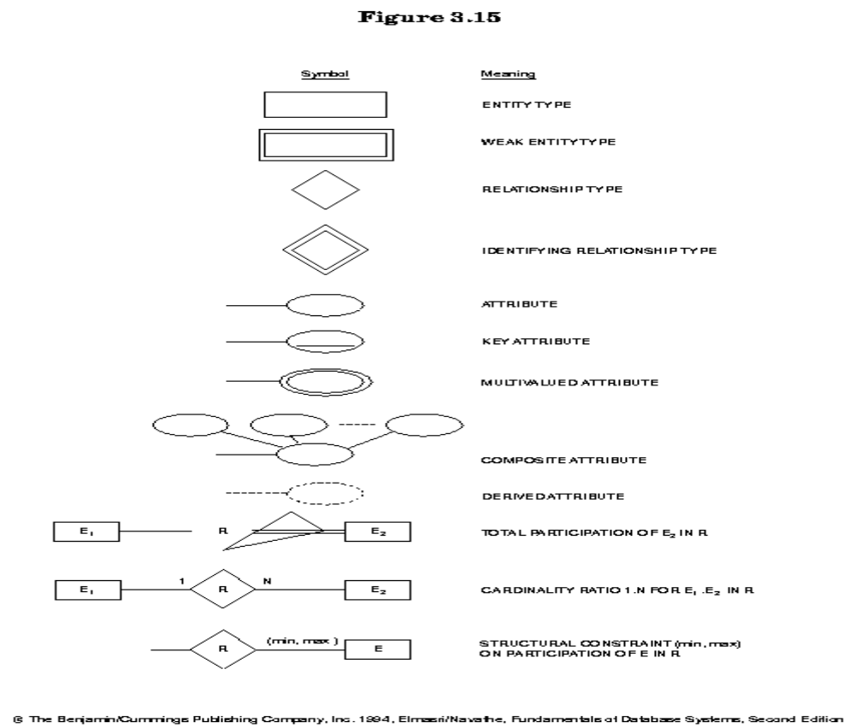

Standard Notations – Data Flow Diagram
Input /output | 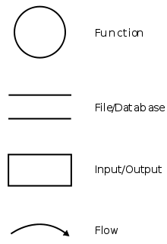
File /data store | 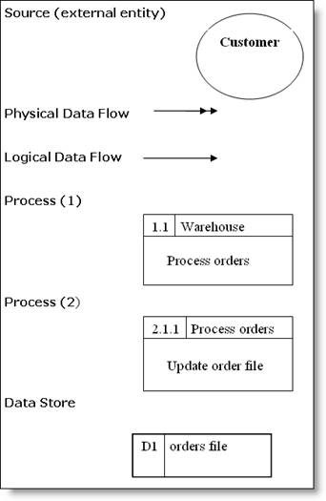  or
Data flow

For process / function either | Or

For Object Oriented Approach

Standard Notations – UML Diagram
Pattern Instance of Command Pattern

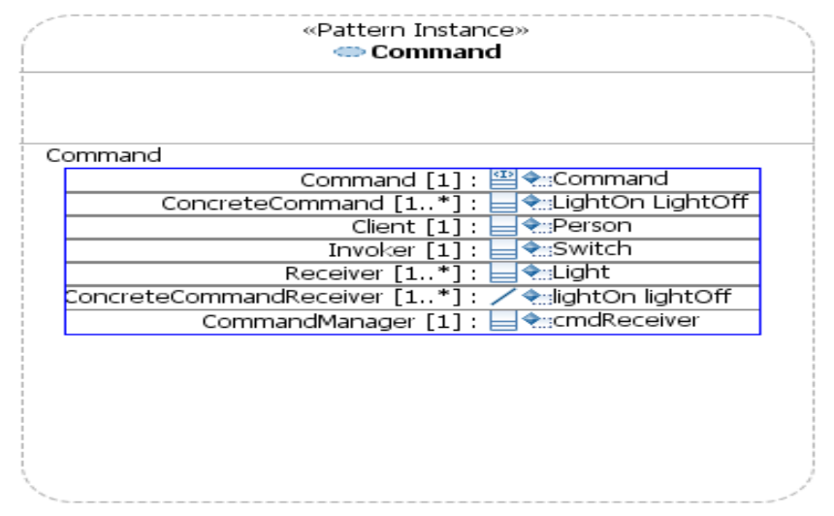

Use case Diagram for a switch connected to a light source
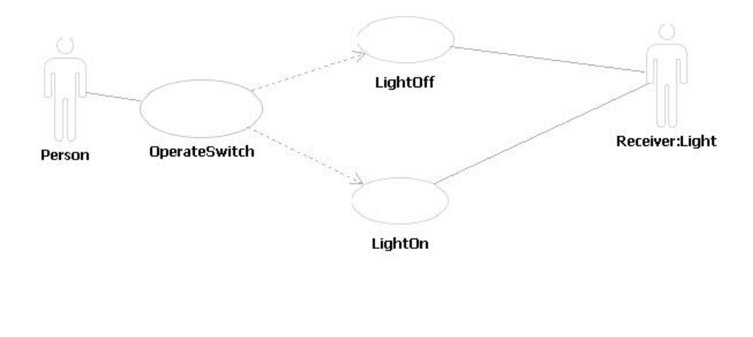

Activity Diagram for Switch connected to a light source
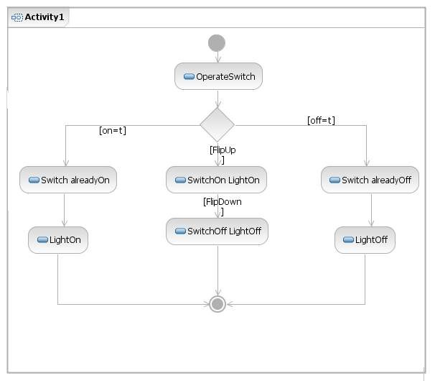

Class Diagram for Switch connected to a light Source
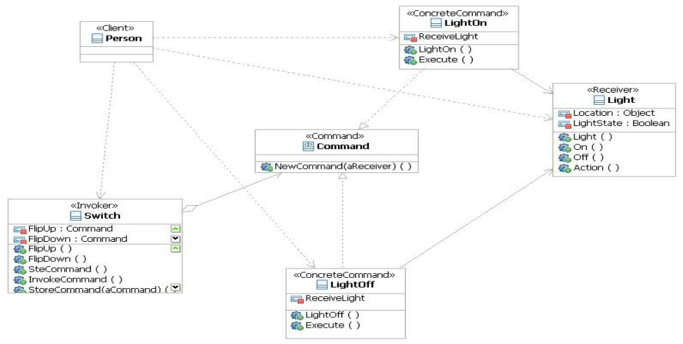
Sequence Diagram for Switch connected to a light Source
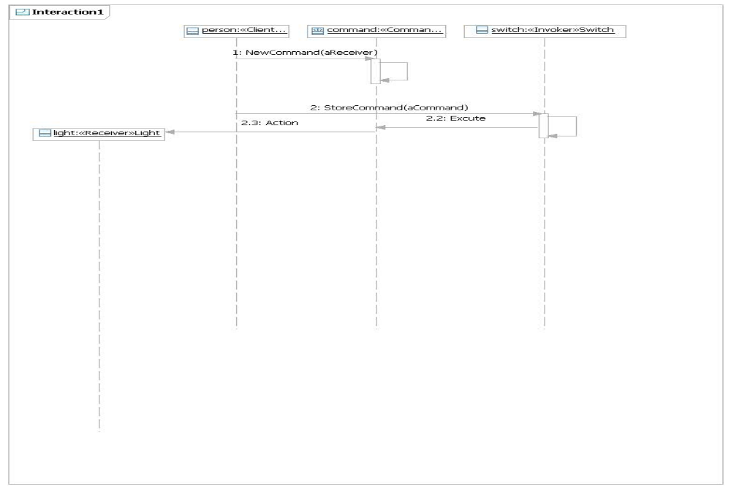

Communication Diagram for Switch connected to a light Source
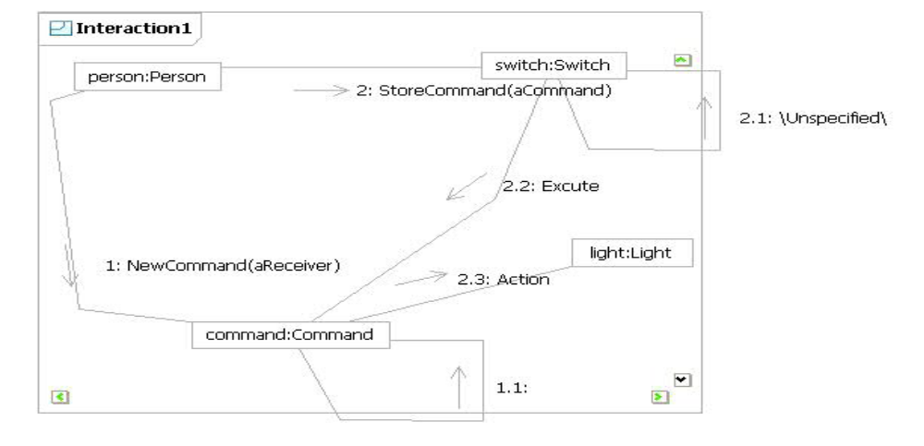
State machine diagram for a Switch connected to a light source

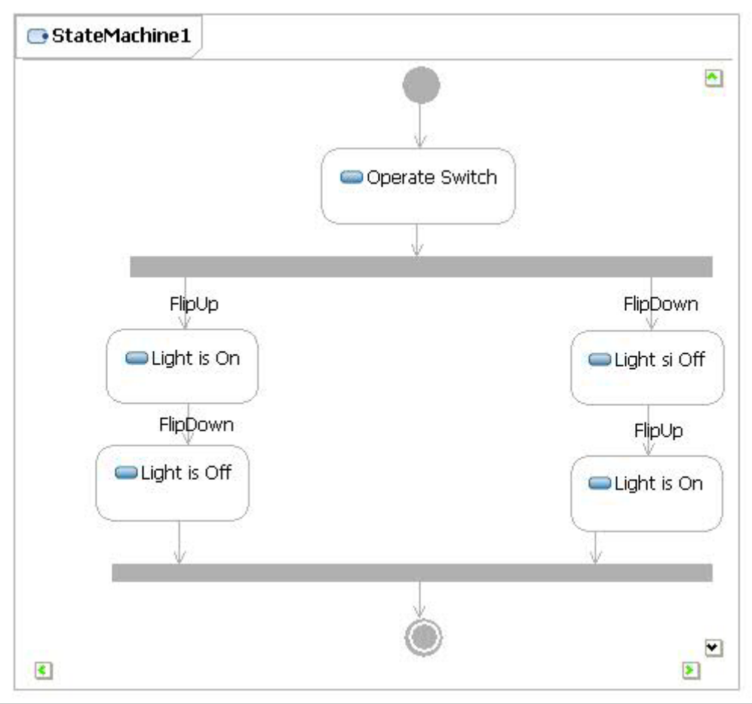

VTU Guidelines for the Preparation of Project Reports

- Printing Area: The margins should be: Left: 1.25”, Right: 1.00”, Top and Bottom- 1.00”. The text should be justified to occupy the full line width, so that the right margin is not ragged, with words hyphenated as appropriate. Please fill pages so that the length of the text runs to the right margin.

- The report must be printed on one side only. Please use a high-resolution printer, preferably a laser printer with at least 300 dpi. Project reports must be printed neatly on one side of the paper on a A4 size bond paper. The reports submitted to the department/guide(s) must be hard bounded with dry tone Photocopy..

- Abstract: The abstract should summarize the contents of the report and should contain at least 150 and at most 350 words. It should be set in 12-point font size. There should be two blank (10-point) lines before and after the title ABSTRACT.

- Layout, Typeface, Font Sizes, and Numbering: For the main text, please use 12-point type and 1.5 line spacing. We recommend using Times New Roman fonts. Italic type may be used to emphasize words in running text. Bold type and underlining should be avoided.

- Headings.
The chapter headings should be in capitals and must be separated from the other text by 24point line space.

Headings should be in the form where each word is capitalized (i.e., nouns, verbs, and all other words except articles, prepositions, and conjunctions should be set with an initial capital) and should, with the exception of the title, be aligned to the left. The font sizes are given in Table 1.

Here are some examples of headings: “Criteria to Disprove Context-Freeness of Collage Languages”, “On Correcting the Intrusion of Tracing Non-deterministic Programs by Software”, “A User-Friendly and Extendable Data Distribution System”, “Multi-flip Networks: Parallelizing GenSAT”, “Self-determinations of Man”.
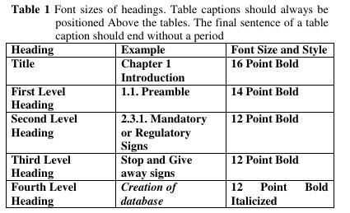
Figures and Photographs

Check that in line drawings, lines are not interrupted and have constant width. Grids and details within the figures must be clearly readable and may not be written one on top of the other. The lettering in figures should have a height of 2 mm (10-point type). Figures should be scaled up or down accordingly.
Figures should be numbered and should have a caption which should always be positioned under the figures, in contrast to the caption belonging to a table, which should always appear above the table. Please center the captions between the margins and set them in 9-point type (Fig1.1 shows an example). The distance between text and figure should be about 12 point spacing, the distance between figure and caption about 6 point spacing
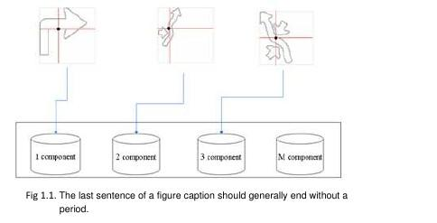

6. Formulas
Displayed equations or formulas are centered and set on a separate line (with an extra line or halfline space above and below). Displayed expressions should be numbered for reference. The numbers should be consecutive within each section or within the contribution, with numbers enclosed in parentheses and set on the right margin. For Example
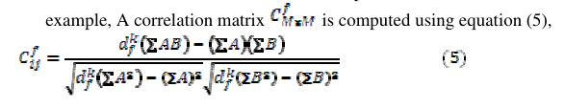

7. Program Code

Program listings or program commands or algorithms in the text are normally set in typewriter font, e.g., CMTT10 or Courier.
Example of an Algorithm is
Algorithm-1: Database Creation (Mean and Standard Deviation based approach) Input: Static images of potential traffic sign
Output: Database created. Methodology:
For each input image do
Step1: Preprocess the image as explained in section 4.3.1
Step2: Calculate the number of components in a sign as explained in section 4.3.1. Step3: calculate a feature vector as mentioned in section 4.3.2.1.

Step4: Store the feature vector computed in step 3 in the corresponding database, based on number of components present in the sign.
For End. Algorithm End.

8. Footnotes/ Header
Footnotes/Header should appear at the bottom of the normal text area, with a line of about 5 cm in Word set immediately below/above the text.
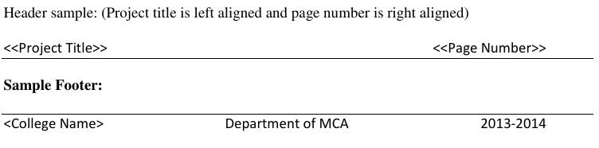

9. References
The list of references is headed “References” and is assigned a number with square brackets in the decimal system of headings. The list should be set in small print and placed at the end of the dissertation, in front of the appendix, if any exists. Please do not insert a page break before the list of references if the page is not completely filled. An example is given at the end of this information sheet. For citations in the text please use square brackets and consecutive numbers: [1], [2], [3] etc.

10. Page Numbering
Reports must be printed with page numbers on the top right corner.

11. The total number of reports to be prepared are three

One copy to the concerned guide ,
One copy for University and
One copy to candidate
Two CD’s having soft copy of Project report (for department purpose)

12. Before taking the final printout, the approval of the concerned guide is mandatory and suggested corrections, if any, must be incorporated.
- Every copy of the report must contain (See formats towards the end of this document)
  - Outer title page (parrot green) with a plastic cover
  - Inner title page (White)
  - Certificate in the format enclosed, only certificate will be signed by following: Principal, HOD ,Internal guide and External guide (if project is carried out in company) Guide and/or Co-guide (if project is carried out in college)

- The organization of the report should be as follows
o Inner title page
- Certificate
- Project Completion certificate from Company / College
- Declaration (by student)
- Acknowledgement
- Abstract
- Table of Contents
- List of table and figures
- Main body of project

Proper attention is to be paid to the technical contents as well as to the organization of the report and clarity of the expression. Care should be taken to avoid spelling and typing errors. The student should note that report (write-up) forms the important component in the overall evaluation of the project.

Sample content (more suitable for Application oriented projects) is provided and number of pages may be 40-70 which can be modified as per guide’s instructions depending on the project under development.

The respective guides can decide how the content of the project report must be organized if the project is research oriented, as a specific format cannot be defined for various domains of research problems.

